House Viewing Checklist

Incorporating Richard Ellis & Co Solicitors

If you are planning on buying a home it may be as well to have a Checklist to help avoid any pitfalls.

- Take your time.
This is an important decision. Don’t be afraid to ask for a second or third viewing.

- Orientation and Light.
Which way does the house face? Is the garden South facing? Go during daylight if you can and see how the natural lighting affects each room.

- Is the property structurally sound?
Are there any signs of subsidence or cracks in the wall. Are there any signs of damp, either visually or is there a damp smell at all? Are the walls watermarked or is the paint flaky? Has the room been recently repainted, perhaps to cover up signs of damp? What is the condition of the roof and is any of the roof flat? What about the chimneys, are they in good condition?

- Land/Garden.
Ensure you know the extent of the property and how far the land goes. Is there space for parking? Is the garden overlooked? How much maintenance does it require? What state are any fences in? Has the garden ever been flooded?

- Photos.
Ask if you can take pictures if you think this would help you and assist you in remembering this property better against other properties you may be viewing.

- Check out the storage space.
Storage space can sometimes be scarce especially in new builds! Is there enough room for your hoover and ironing board?

- Energy.
What does the Energy Performance Certificate say? With rising fuel costs this could be important.

- What is the loft like?
Not just structurally but is there potential for conversion. Is it easy to access? If it has been converted, do the sellers have the Building Regulations Completion Certificate?

- Doors and Windows
What condition are the frames in and are they single or double glazed? Do the windows have locks on them and are the keys available?

- Plumbing.
Do the taps work and what is the water pressure like. How old is the boiler and does it have any outstanding warranty left.
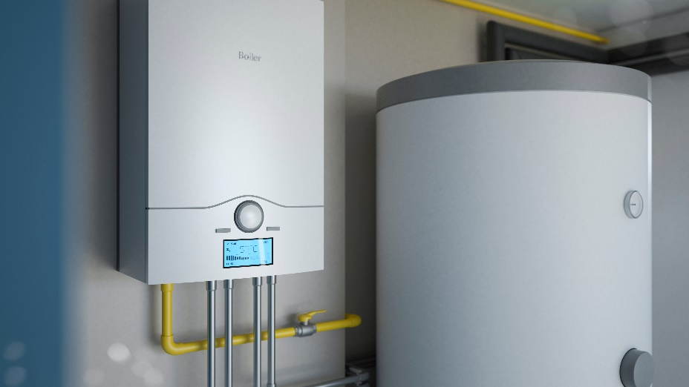

- What is the neighbourhood like?
Are there any amenities like a local shop, pub, playing fields etc which you can walk to? What are the local schools like, should you need these. Are you over flown by noisy aeroplanes or are there noisy roads nearby? Is there good public transport should you need it? Do you feel safe in the area? Visit the area both during the day and at night to get a feel for the property.

- In general.
Is there good mobile phone coverage? What about the broadband coverage? Is there scope for adding value to the house? Is it in a conservation area or is the building itself listed? Is there a working burglar alarm?

At the end of the day did you feel comfortable in the property? Did you feel that you could make it your home? These are perhaps some of the most important considerations of all!

Once you have decided you have found your dream home, it’s really important to make sure that there are no hidden legal problems and that your purchase can continue as smoothly as possible. Make sure you choose the right lawyer to help you by calling us now on 0113 200 7480 or email info@averywalters.com.

